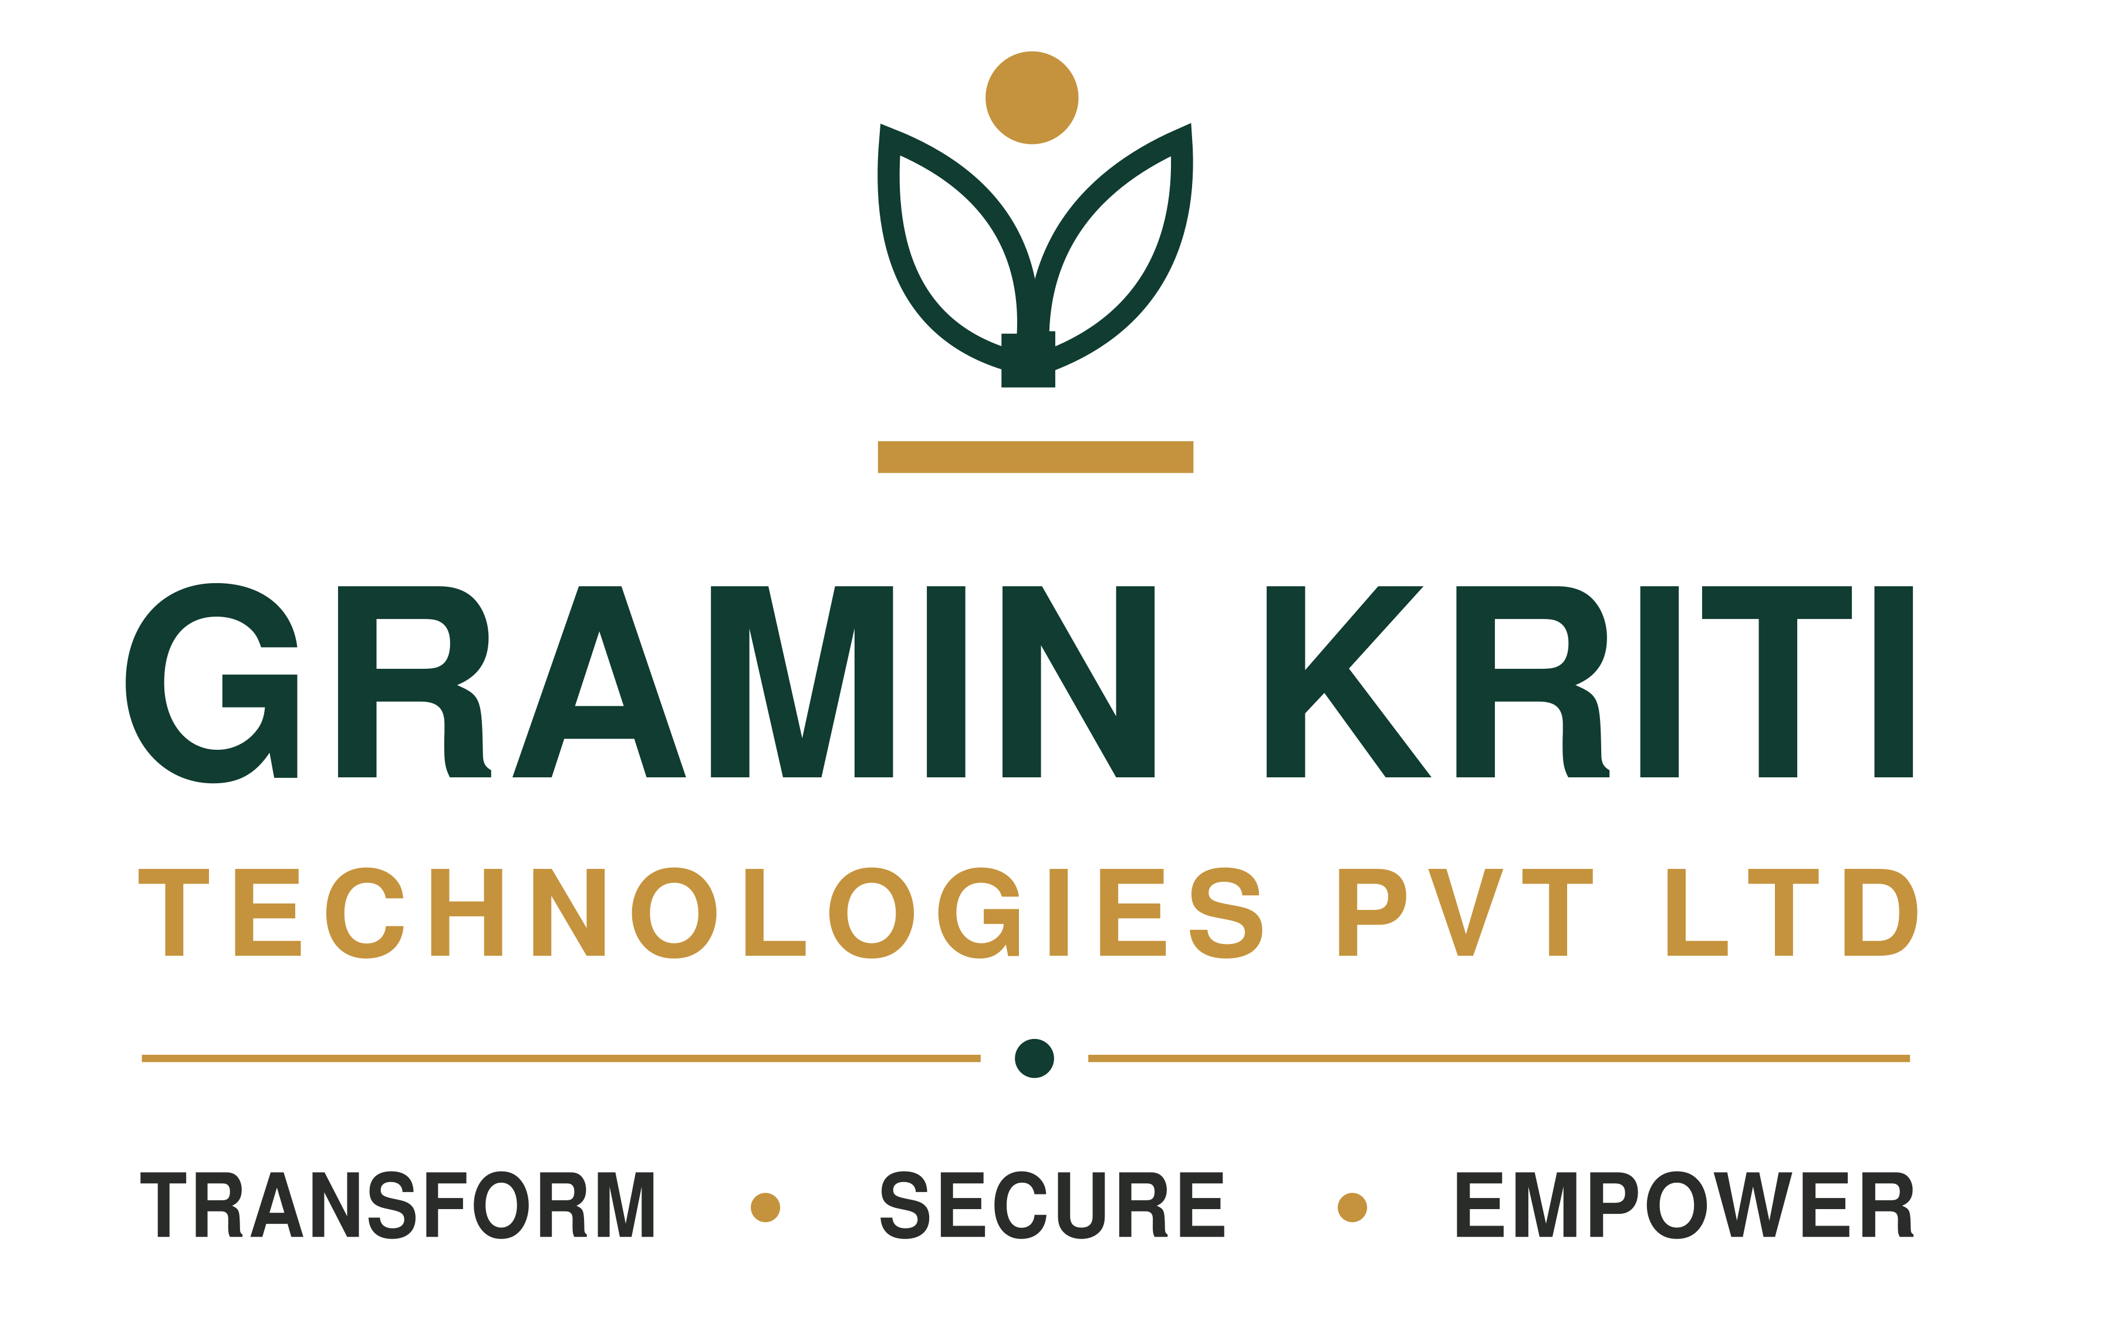

Kriti Voice
  - Multilingual discovery and transformation
Hear how work really happens
A consultant-led platform that lets people speak in their own language and turns their conversations into verified evidence for process improvement.

Two ordinary phones. A conversation in each person’s language. A process map grounded in what people actually said.
For organisations whose critical work happens in branches, on the shop floor, in the field and across languages.
PRODUCT BROCHURE | OCTOBER 2026

02 / PRODUCT OVERVIEW

Hear the people closest to the work
Better discovery starts with the people who do the work, in a language they can use confidently.
Field officers, collection agents, branch staff, farmers and customers often do not speak the consultant’s language. Discovery can end up hearing mostly managers, with redesign built on a summary of a summary. Kriti Voice helps close that gap.

How an interview works
01 Prepare Gramin Kriti creates a question guide and a glossary of client terms, including product names, internal jargon and local words. Checked translations let key questions play instantly with consistent wording.
02 Pair two phones The consultant opens the interview on one smartphone. The participant scans a QR code on the other. Both use a mobile data connection; nothing is installed.
03 Ask for consent The participant sees the consent notice in their own language. Recording starts only after agreement. If they decline, the session ends with nothing stored.
04 Talk naturally Each person speaks their own language. The participant hears translated questions; the consultant reads translated answers or listens through an earphone. Translation latency is visible on screen.
05 Follow the guide Topics are marked as covered. The consultant’s phone can suggest follow-up questions when an answer needs more detail, such as a missing number.
06 Close with a record Separate audio is recorded for each speaker, alongside a combined recording. Both sides are transcribed in the original language and in translation.

Language coverage
English US and India, Hindi, Marathi, Spanish Mexico and Latin America, Portuguese Brazil and French. Live speech, translation and voice have been tested in English, Hindi, Marathi and Spanish.
Marathi and Mexican Spanish recognition use Google preview models, so consultants review these transcripts more closely.

03 / PRODUCT OVERVIEW

Turn conversations into checked evidence
Every finding in the client output links back to the exact sentence behind it and is checked by a Gramin Kriti consultant.

After each interview
AI analysis prepares a draft summary and the participant’s role in the process. It identifies process steps, inputs, outputs, systems, activity time and waiting time. Gaps, risks and improvement ideas are graded by severity, with open questions for the next interview.
Activity frequency and duration provide a basis for sizing effort. During the conversation, suggested follow-up questions help the consultant probe missing details.

Human review before publication
A consultant corrects the transcript where needed, then accepts, edits or rejects each finding. Only verified material moves forward into the client view.

Across the engagement
One shared process map A merged swim-lane map brings together every account. Each step shows how many people described it and the confidence in its evidence. Overlaps, conflicting accounts, gaps and bottlenecks remain visible.
Recurring themes Repeated gaps, risks and quick wins are linked to the interviews behind them.
Coverage dashboard Interview progress is shown against the engagement plan by department and location.
Reports for decisions Interview-level and engagement-level PDFs are available in English by default or another supported report language.

A controlled client view
Clients see verified, anonymised material. Pseudonyms replace names; names, phone numbers and IDs are removed from quotes. Sponsors receive read-only access to what Gramin Kriti has published to them.

04 / PRODUCT OVERVIEW

Carry evidence into lasting change
Gramin Kriti delivers the full transformation service. The platform supports the first three phases today.
The same checked evidence travels from mobilisation through diagnosis, design and delivery, so recommendations remain connected to what people actually said.
Phase | Gramin Kriti delivery | Platform support
Mobilise | Agree scope, sponsors and success measures. Plan interview coverage. | Available now  Isolated workspace, interview plan, roles and access.
Discover | Interview people doing the work in their own languages. | Available now  Two-phone translation, consent, recordings, transcripts and topic tracking.
Diagnose | Build a shared view of how work happens. | Available now  Reviewed analysis, merged process map, recurring themes and focus-module KPIs.
Design | Co-design the future process and prioritise improvements. | In development  Future-state map beside the current map, with changes linked to evidence.
Deliver and sustain | Support rollout, training and change management. Track results. | In development  Baseline KPIs, improvement tracking and follow-up interviews.

Service continuity
Until Design and Deliver and sustain are built into the platform, Gramin Kriti delivers them through its consulting service using the same verified evidence.

05 / PRODUCT OVERVIEW

Use it wherever work crosses languages
Hear from people in the field, on the shop floor, in branches or in villages, alongside management.
Industry | Processes in focus | People heard
Banking and finance | Collections, recovery, loan origination, branch operations and KYC. | Collection agents, branch staff and borrowers.
Agriculture and agri-finance | Equipment and input finance, procurement, onboarding and crop advisory. | Farmers, field officers, dealers and aggregators.
Manufacturing | Shop-floor flow, maintenance, quality and safety. | Operators, supervisors and contract workers.
Retail and distribution | Store operations, route-to-market, last-mile delivery and returns. | Store staff, distributors, delivery partners and retailers.
Logistics | Warehousing, transport handovers and vendor management. | Drivers, warehouse teams and vendors.
Healthcare | Patient intake, discharge, pharmacy and supplies. | Nurses, technicians, community health workers and patients.
BPO and shared services | Handovers, exception handling and client onboarding. | Agents, team leads and client staff.
Government and NGOs | Scheme delivery, beneficiary journeys and grievances. | Beneficiaries, frontline workers and local officials.
Post-merger integration | Combining ways of working across regions or countries. | Teams on both sides, in their own languages.
The approach also supports internal audits, compliance reviews, customer and farmer research, employee listening, culture surveys and acquisition due diligence.

06 / PRODUCT OVERVIEW

Configure it for your organisation
Client-specific settings adapt the platform to a new industry, country or process without rebuilding the core platform.
Languages and reports Choose interviewer, participant and report languages per engagement. Additional languages can be added as the underlying speech services support them.
Participant profiles Use up to 30 custom profile fields, such as grade, shift, branch, crop or customer segment. Coverage dashboards use the same fields.
Guides and vocabulary Set question guides by role and use the client’s own glossary to preserve relevant vocabulary in translation.
Process focus modules Add industry checklists and KPIs. New modules can be built for a process; the first addresses collections for asset finance provided in kind rather than as cash loans.
Roles and permissions Five roles govern access per client: admin, lead, reviewer, interviewer and client viewer.
AI vendor choice Google, AWS, Microsoft Azure, Anthropic or OpenAI can be selected per client through the admin panel, in line with the client’s vendor policy.
Hosting choice Use Gramin Kriti’s US environment, EU hosting on request or a dedicated copy in the client’s own cloud account.

A collections example
The first focus module includes days past due, cure rate, roll rate and days to first contact. Other modules can be developed around the process and measures agreed for the engagement.

07 / PRODUCT OVERVIEW

Protect the conversation and its evidence
The platform is designed around ISO IEC 27001 2022. It is not yet independently certified.
Client separation Each client has its own database, storage and Google Cloud Key Management encryption key. No database login can access two clients’ data.
Encryption Data is encrypted in transit and at rest. Participant names and transcripts are also encrypted field by field. Disabling a client’s key at engagement close makes remaining encrypted data unreadable.
Strict access Two-step verification and five roles limit access. Participant names are visible only to admin, lead and reviewer roles.
Tamper-evident records Audio access and changes to findings are logged. Entries are chained so changes to earlier records can be detected.
Network protection The database is on a private network. A web application firewall and country restrictions screen traffic.
Recorded consent The exact notice, language, version and time of consent are retained. Engagement wording follows local requirements, including India’s DPDP Act 2023 and Mexico’s LFPDPPP, with local counsel approval.
Data location Google Cloud in the United States is the default, with EU hosting on request. A dedicated client-cloud environment offers the client its own keys and logs.
Approved AI vendors Google Cloud is the default for speech, translation and analysis. Agreements name permitted vendors. Before use, vendor terms are checked to exclude training on submitted data.
Controls are mapped to all 93 ISO IEC 27001 2022 Annex A controls. Mapping and design alignment do not constitute independent certification.

08 / PRODUCT OVERVIEW

Combine conversation with process insight
Kriti Voice brings consultant-led interviews, live language support and reviewed process evidence into one workflow.
Alternative | Primary strength | Kriti Voice contribution
Human interpreter | Language support and reading the room. | Two-phone translation, recorded conversations and structured evidence without a separately booked interpreter.
Meeting transcription | Notes and transcripts from meetings. | Live two-way language support plus process analysis and review.
Video-call translation | Translated conversation within a meeting platform. | An in-person two-phone workflow with a participant consent step and process evidence.
Phone translation apps | Quick multilingual conversation. | Client glossary, question guide, separate recordings, reviewed analysis and client-separated data.
Research repositories | Organising and tagging existing recordings. | Support during the interview and evidence carried into a merged process map.
AI-moderated research | Remote interviews at scale. | A consultant leads the conversation, probes and builds rapport.
Process mining | Flows reconstructed from system logs. | Manual, paper and field steps, including reasons for workarounds.
Surveys | Standardised questions at volume. | Spoken, open conversation with follow-up questions.
Process mining and surveys can complement interviews, helping measure the patterns and issues that discovery uncovers.

09 / PRODUCT OVERVIEW

Choose an engagement model
Start with a discovery sprint, extend into a transformation programme or equip your own teams to run discovery.

Discovery sprint
Gramin Kriti consultants prepare the interview plan and guide, conduct interviews across departments and locations, and deliver a verified process map, gaps, quick wins, engagement report and leadership readout. Suits a first review of one process or function.

Transformation programme
Gramin Kriti works with your team from discovery through future-state design, the improvement roadmap, implementation support and KPIs measured against a baseline. Suits organisations seeking delivery beyond diagnosis.

Managed platform licence
Your teams run interviews after Gramin Kriti training, using an isolated workspace, guides, glossary and AI analysis, with support and quality review. Plans scale by interview volume; speech, translation and analysis quality are consistent across plans.

Dedicated environment
Your teams or Gramin Kriti use a deployment in your own cloud account, with your keys, logs and AI vendor choice. Suits regulated organisations and groups with strict data-residency requirements.

Agree the scope together
Each model can include process focus modules. Pricing, sprint duration and interview volumes are agreed during scoping. A short live demonstration in your own language can be arranged before commitment.

10 / PRODUCT OVERVIEW

See Kriti Voice in your language
Start with a short conversation about the process you want to understand and the people you need to hear.

01 Scope Agree the process, participant groups and locations.
02 Demonstrate See two phones working in your team’s language.
03 Set up Prepare the isolated workspace, guide, glossary and consent wording approved by local counsel.
04 Interview Run consultant-led interviews on site or remotely, with analysis reviewed after each interview.
05 Read out Review the verified process map, themes and improvement priorities with leadership.

Arrange a demonstration
vedaansh@graminkriti.com
Gramin Kriti Technologies Private Limited
Product information as at 20 October 2026. Photography is illustrative. Sources informing the original category comparison include Microsoft Support, Sally, Dovetail, Outset, E3 Magazine and TechCrunch. Photographs: Unsplash.

